Phase I and Phase II Results – Montana (MT)

A. Introduction

Montana was one of the last hold-outs in the nation's financial crisis. The state had one of the highest employment rates in the nation due to growth in the energy industry, but as natural gas companies curtail operations housing markets will feel the impact. Thousands who work in the energy fields are fleeing the state. However, comparatively fewer foreclosures in Montana will also act to soften the blow.
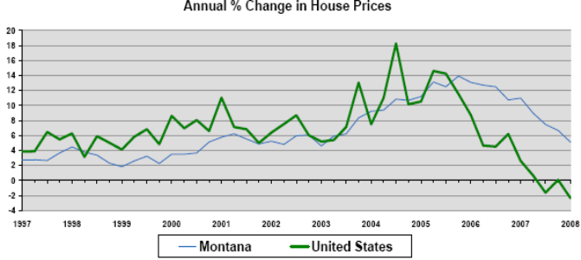
Source: Freddie Mac's Conventional Mortgage Home Price Index

Employment Growth
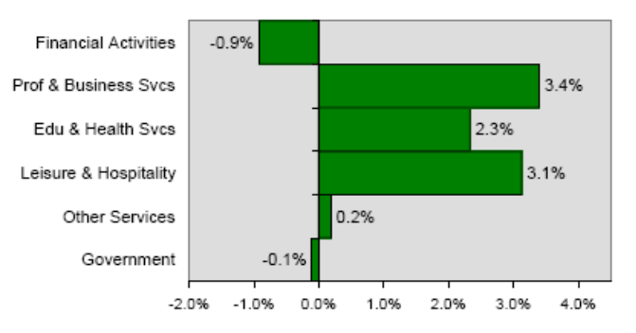
Source: Bureau of Labor Statistics, % change year ago

A vigorous expansion over the last 20 years has produced a growing business community in Missoula. But the national recession is putting a damper on Missoula. A sixth of the community's population now lives under the poverty line making it impossible for them to become homeowners. After 15 years of housing values going up, Missoula is forecast to deflate 4.5% for the year.

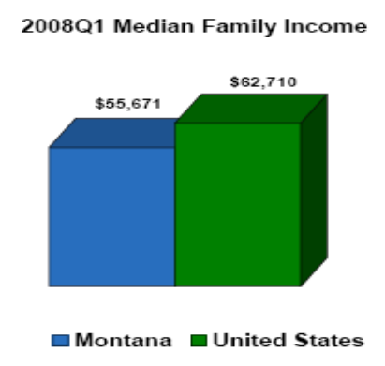
Source: US Census Bureau, Moody's Economy.com

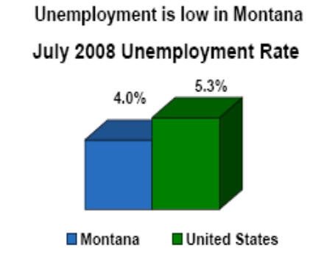
Source: Bureau of Labor Statistics

Montana has been largely isolated from national trends. There wasn't much subprime or creative financing offered during the nation's real estate boom in Montana with Alt A adjustable rate mortgages, which acted to at least protect the state's markets.

Bozeman has one of the highest numbers of home businesses in the country with many of its residents tied to the development of the growing World Wide Web, and it's constantly rated as one of the most live-able cities in the country for entrepreneurs. With just under 50,000 residents, Bozeman offers amenities usually found in larger urban settings and plenty of year round outdoor activities. Bozeman's attraction should endure the economic downturn as housing sales turn sluggish with values forecast to decline just 2.8% through the year's end.

Montana Leads 2009 Top Housing Market Forecast.

B. Plot of Lagged Predictors vs. HPI (simple returns)
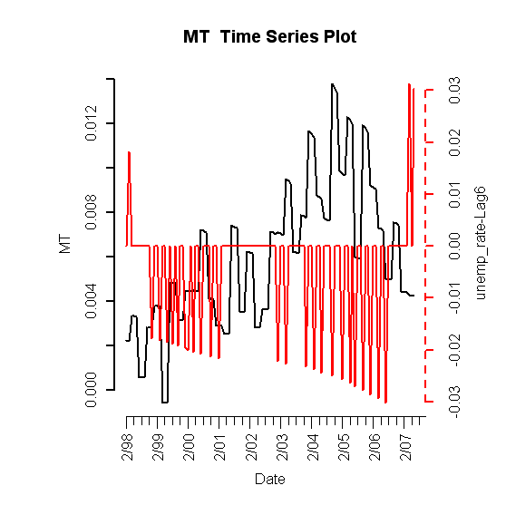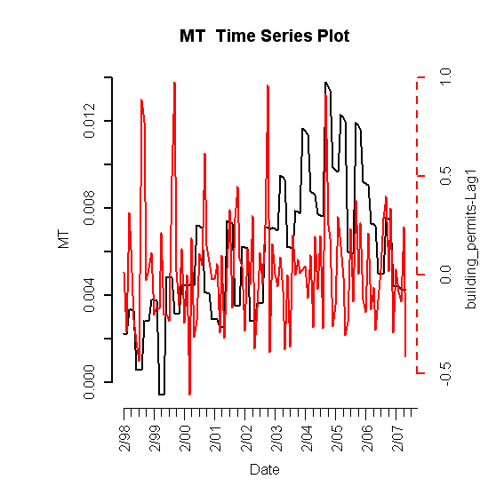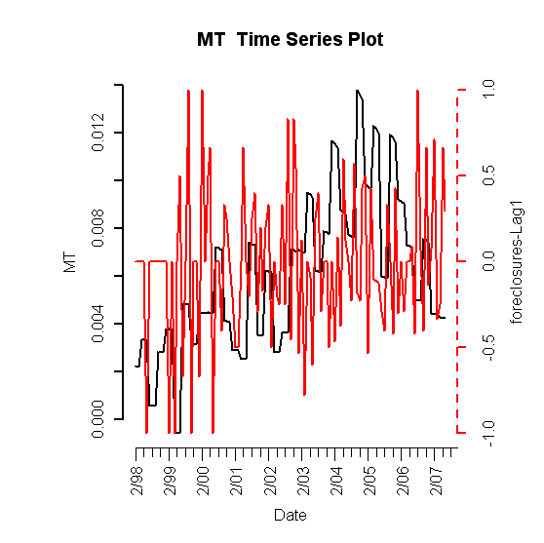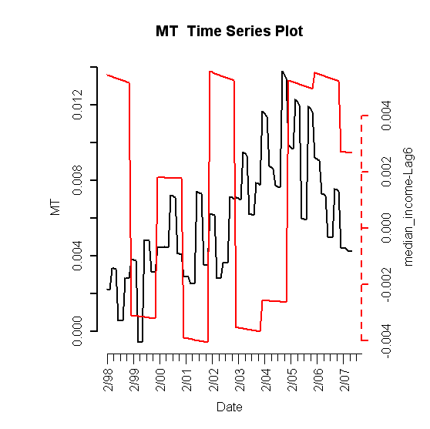

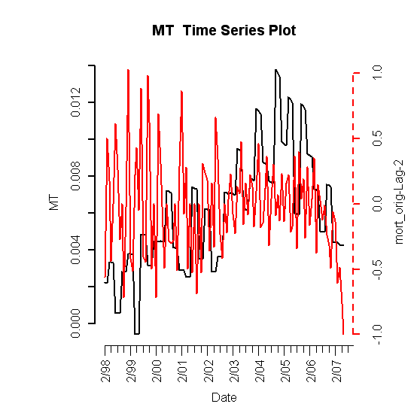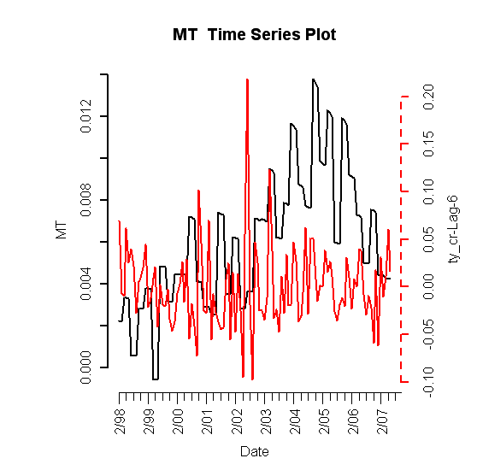

Figure I.1: Lagged predictors vs. Montana HPI

C. Final Multivariate Model

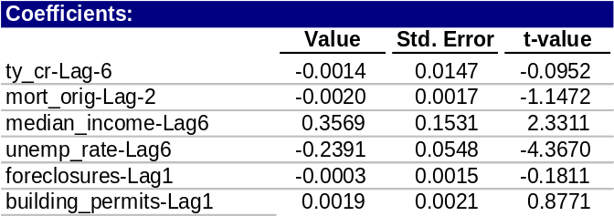
Table 1: Fitted drift model

1. Phase I: Drift Model

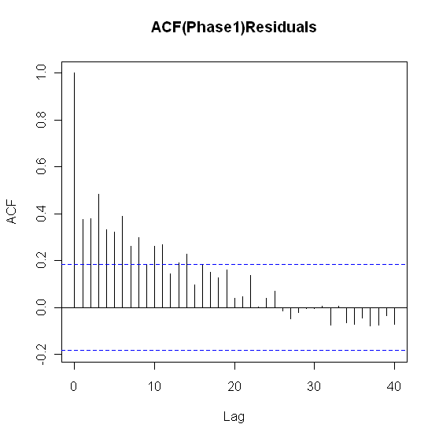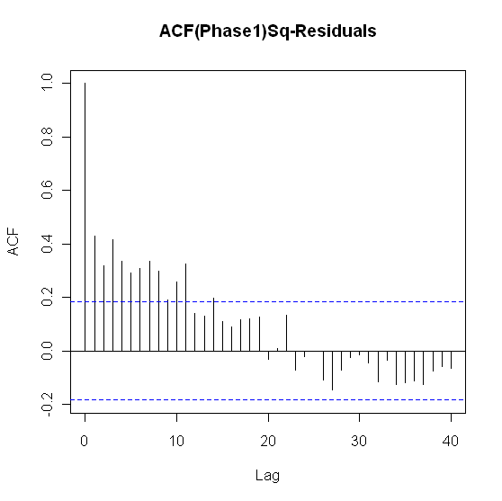
Figure I.2: ACF of residuals (left) and squared residuals (right) of fitted linear model

2. Phase II: Volatility Model

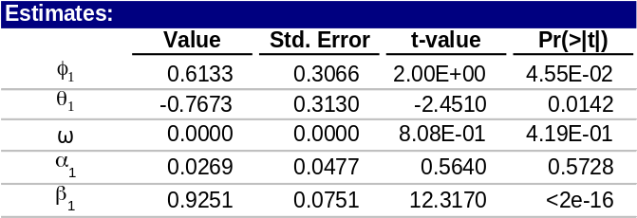
Table 2: Montana fitted volatility model

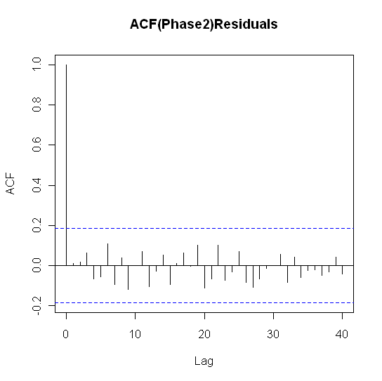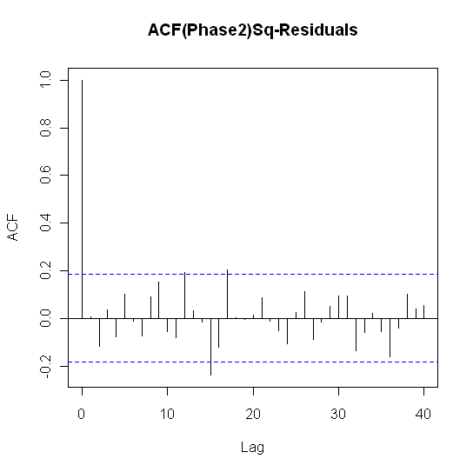
Figure I.3: ACF of residuals (left) and squared residuals (right) of the Phase II model for Montana

3. Model Checking Diagnostics

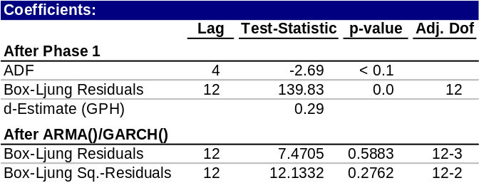
Table 3: Statistical test results for complete model

D. Fitted vs. Actual Plots

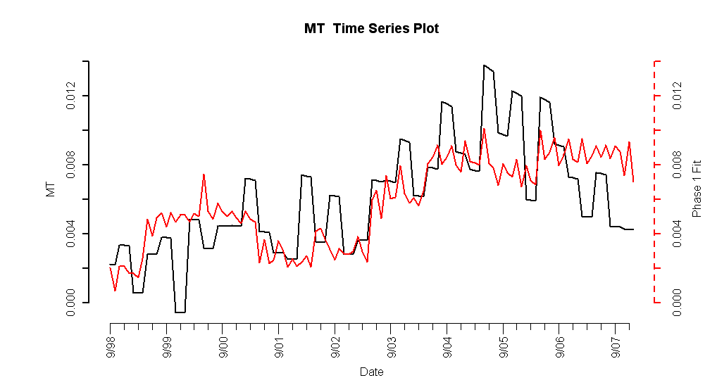
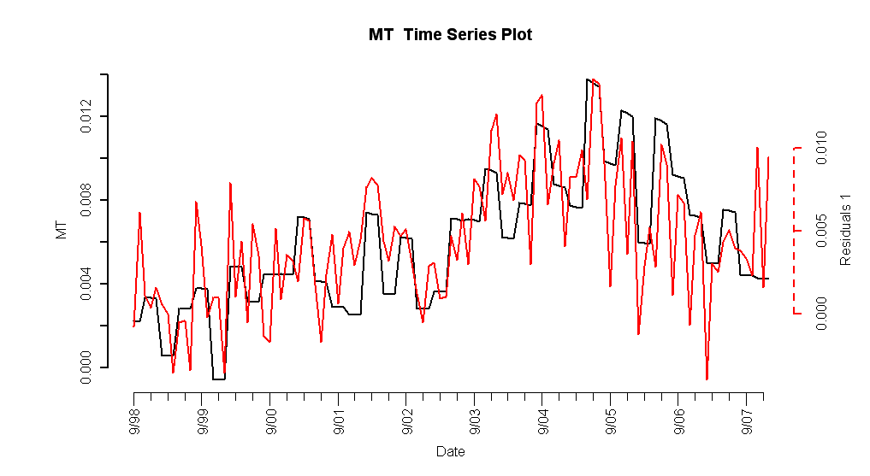
Figure I.4: Fitted Phase I vs. Montana HPI (top) and residuals (bottom)

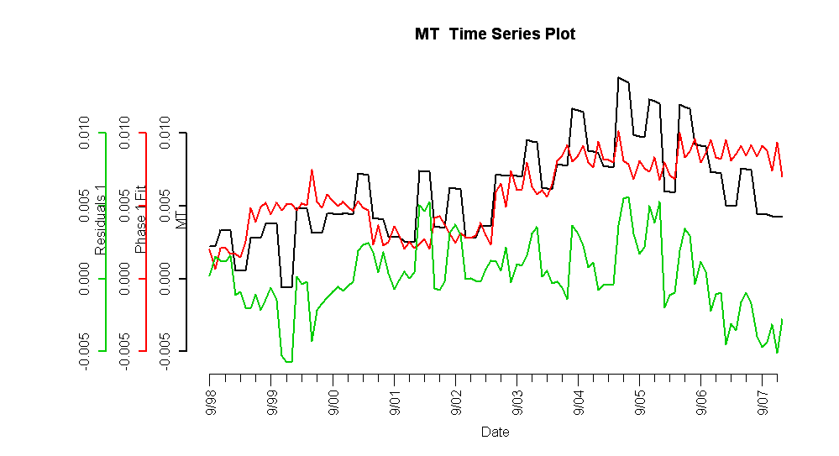

Figure I.5: Fitted Phase I vs. Texas HPI and residuals

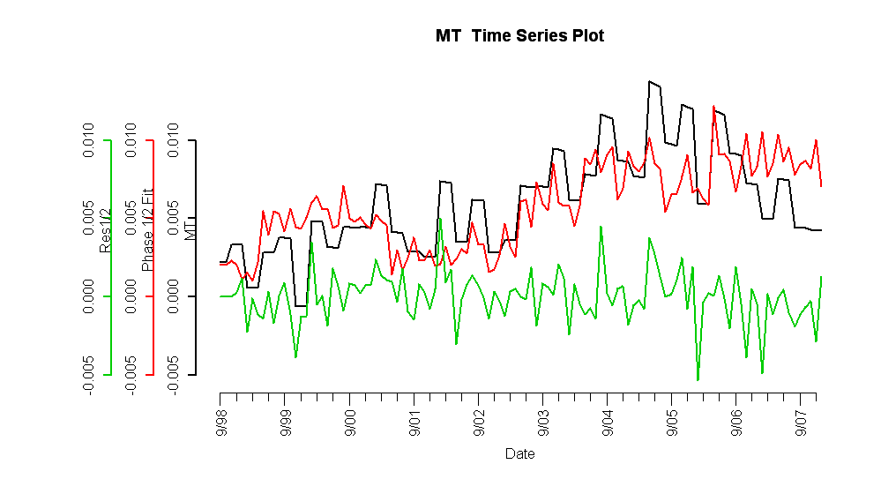

Figure I.6: Complete fitted model vs. Texas HPI and residuals

E. Forecasts
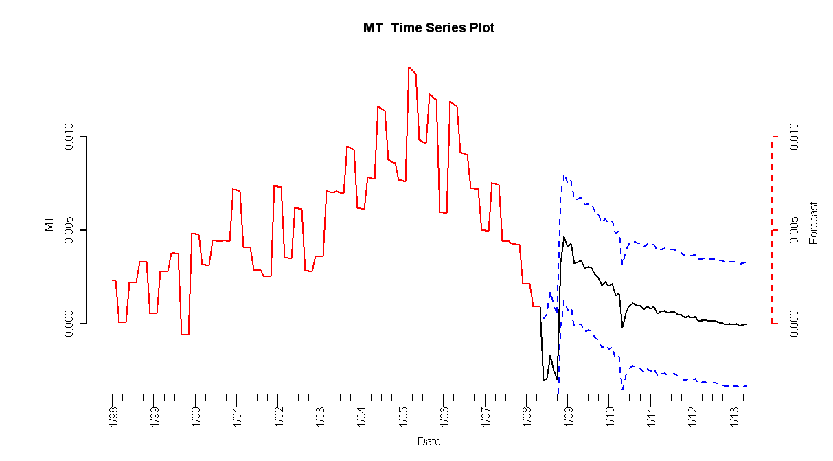

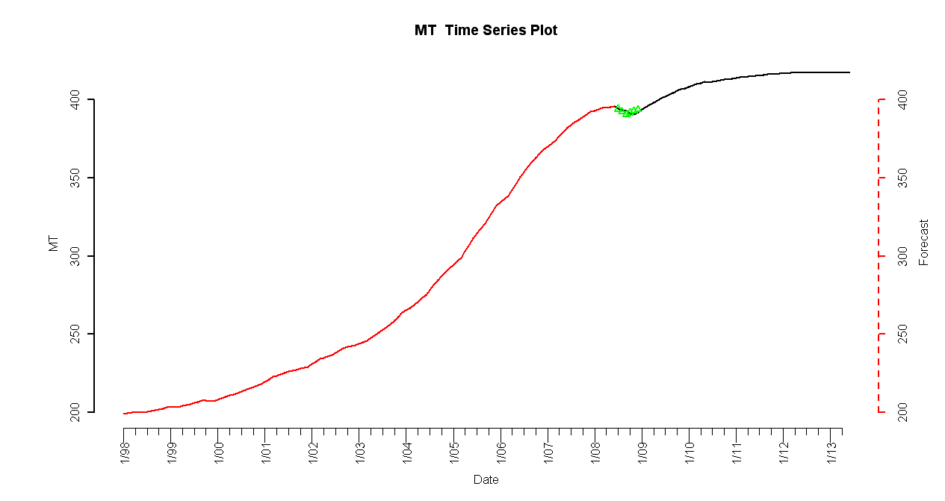
Figure I.7: 5-year forecasted simple returns (top) and forecasted HPI (bottom)

